Ford City Arts & Heritage Festival 2016 Vendors Application - Sept 17-18
Once completed please save and e-mail to fordcitymarket@gmail.com or print and submit to the Standard Printing 1076 Drouillard Rd Windsor, ON. Thank you!
Please read carefully and fill out completely. If you need assistance with the application please call 519-915-9583.
Festival Business Hours: DAY 1: 11am-5pm Saturday September 17th
DAY 2: 9am-1pm Sunday September 18th
Set up Time: DAY 1: 9am – 10:30am Wrap-up Time: 5pm-6pm
DAY 2: 8am Wrap-up Time: 1pm
Location: The 1000 Block of Drouillard Road, Windsor ON (see map)
Check the box to indicate if you are participating in DAY 1, DAY 2 or both days.
Day 1 ($35) ☐
Day 2 ($20) ☐
Both Days ($50) ☐
Site Notes:
- The market will be on the street in the middle of the 1000 block of Drouillard between Whelpton and Richmond. Once street is closed there is no car access.
- Free parking on side streets following posted signage.
- There is an ATM at Charron’s Variety on Whelpton
- Estimated Attendance: 2000-2500 people
- You must provide your own TENT, TABLE, CHAIRS, and EXTENSION CORDS etc. if you want them.
Vendor Fees & Payment:
Stalls are each 8’ x 6’ and you must SUPPLY YOUR OWN TABLES, CHAIRS and TENT if you choose.
Stalls are $35 on Day 1 and $20 on Day 2*. If you do both Days the price is $50, save $5. Fees to be paid in advance to The Ford City Business Improvement Association by cash or cheque no later than the day before OR by debit or credit card the day of at the market with Alana Usakov the Market Coordinator, she will have a debit machine.
*Discount NOTE: If you are a Ford City Market Vendor or a FCRA Sunday Market Vendor you will get a discount. If you are a non-profit promoting your organization the space is free but we do require you to fill out a Vendor Application and submit it.
If you are a vendor at the Ford City Market how many markets have you paid to attend? Click here to enter text.
Vendors who attend 5 market days* get $5 off of the cost of the Ford City Arts & Heritage Festival Vendor Space.
*Note: The market days do not have to be consecutive dates. Each day of the market you attend will be tracked by the Head of Recruiting & Promotion who will let you know what your Ford City Arts & Heritage Festival Vendor Space will cost based on your market attendance.
This will be verified by Alana Usakov, contact her at fordcitymarket@gmail.com if you have questions about your attendance.
*Note If you have you been a vendor at the FCRA Sunday Markets you will receive the second day for $10. This will be verified by Cindy Newman, market coordinator, residents@fcnr.org .
DISCLAIMER: Any part of or all of Vendor Fees are NON REFUNDABLE, unless event is cancelled due to weather.
Cheque must be made payable to:
Ford City Business Improvement Association
Application and cash/cheques to be handed in at:
Standard Printing
1076 Drouillard Rd
Windsor, ON
519-974-3500
Email: knielsen@fcnr.org
Drop Off Days and Hours:
Mon-Thurs 9am-12pm, 1pm-4pm
Or call Karlene Nielsen at the Ford City Neighbourhood Renewal to make alternative arrangements for payment drop off (519)-915-9583.
Vendor Information:
Please fill out all the required fields below on next page.

Vendor Name/ Name of Your Business: Click here to enter text.
Main Contact Person: Click here to enter text.
Phone: Click here to enter text.
Email Address: Click here to enter text.
Website Address/Social Media: Click here to enter text.
Brief Description of Items for Sale: Click here to enter text.
Check this box if this is a fundraiser for your Charitable Organization: ☐
Terms and Conditions
Please read the following portion carefully and initial at the bottom if you are agreeable to the terms and conditions.
- Vendors must operate during posted business hours and open and close on time.
- Vendors are responsible for their own belongings. Nothing left over night.
- Vendors are asked to provide visible and attractive signage that clearly indicates the business name, products for sale and the price.
- Prepared food such as baked goods and preserves must have been prepared in a certified kitchen; prepared food must be wrapped or covered and stored to Essex County Health Standards.
- Ford City BIA is not liable for any accident(s) or fine(s) that the vendor receives.
- Business license and insurance is the responsibility of the vendor.
- Site must be returned to original condition after each event.
- No vendor shall smoke at their stall or under a tent.
- Children of Vendors must be supervised at all times.
- Pets are prohibited for vendors.

Please Note: Vendor location will be determined based on type of products for sale. We will do everything possible to locate you where you will be most successful.
I am the vendor and I have read, understand and agree with the information provided herein and will comply with the terms and conditions set out by the Ford City Market Committee.
Vendor Name: Click here to enter text. Initials: Click here to enter text.
Date: Click here to enter a date.
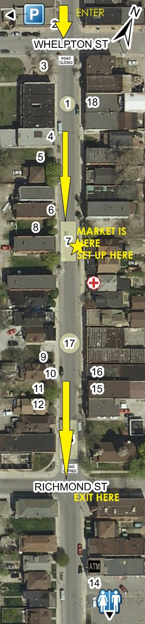
Set Up Instructions for Vendors

DAY 1: SET UP WILL BE BETWEEN 9am-10:30am. DAY 2: SET UP TIME WILL BE 8am-8:45am. Use as much or as little of that set up time as you like. Please do not come early, the street closure will not be ready yet.
Please enter at Whelpton, and proceed to the market area and set up, then exit at Richmond. See map.
*Your spot in the market area is first come first serve.
- A volunteer who is assigned to the market area can watch your table for up to 15 minutes if you need to leave.
- Bathrooms are at 1052 Drouillard along with First Aid.
- Vendor Parking will be behind New Song Church which is the box with the P in the top left hand corner of the map.
- My cell 226-788-2307 will be on if you need help, I will try my best to answer it. If you anticipate any issues contact me to work that out ahead of time.

At all times you are responsible for your booth and products!

