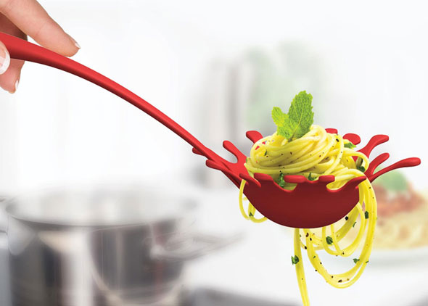

Come Celebrate “SPRING”
with Drouillard Place
A Pasta Evening to be held on Wednesday, March 22, 2017
At Fogolar Furlan Club, Canada Room
Doors open at 5:30pm & Dinner at 6:00pm
50/50 Draw Raffle prizes Handmade Quilt tickets
1 for $3.00 4 for $10.00

Tickets $20.00 Adults, Children 4-12 $10.00
Call 519-253-1073 and ask for Janet to book your tickets

